EXPT NO:3 | Designing Multivariate Patterns
DATE: 12.01.2026 | Designing Multivariate Patterns

PRE-LAB QUESTIONS (PROVIDE BRIEF ANSWERS TO THE FOLLOWING QUESTIONS)
1. Why is multivariate analysis essential in real-world AI problems?
Real-world AI problems involve multiple interacting variables. Multivariate analysis helps understand relationships, patterns, and dependencies among them, improving model accuracy.
2. What challenges arise when visualizing high-dimensional data?
High-dimensional data is difficult to visualize clearly, often leading to cluttered plots, overplotting, and difficulty in interpreting relationships.
3. How does correlation analysis support feature selection?
Correlation analysis helps identify redundant or irrelevant features by showing which variables are strongly related, enabling selection of the most informative features.
4. What are ethical concerns in healthcare data visualization?
Key concerns include patient privacy, data misinterpretation, bias representation, and misleading visual conclusions that may affect medical decisions.
5. Give examples of multivariate data in AI systems.
Examples include patient health records, financial transaction data, sensor data in IoT systems, and customer behavior analytics.
IN-LAB EXERCISE:
OBJECTIVE:
To discover relationships among multiple variables using multivariate visualization.
SCENARIO:
A hospital analytics team studies patient health records to identify relationships between age, BMI, glucose levels, and blood pressure for early disease prediction.
IN-LAB TASKS (Using R Language)
- Generate scatter plot matrix
- Apply color encoding for age groups
- Identify correlated health indicators

CODE:
# Lab Exercise by Student: 23BAD109
library(ggplot2)
library(GGally)
library(dplyr)
# Read healthcare dataset
health_data <- read.csv("3.healthcare_data (1).csv")
# View first few rows
head(health_data)
health_data <- health_data %>%
health_data <- health_data %>%
mutate(Age_Group = cut(
Age,
breaks = c(0, 30, 45, 60, 100),
labels = c("Young", "Middle-aged", "Senior", "Elderly")
))
ggpairs(
health_data,
columns = c("Age", "BMI", "Glucose_Level", "Blood_Pressure"),
aes(color = Age_Group, alpha = 0.6),
title = "Scatter Plot Matrix of Health Indicators"
)
cor_matrix <- cor(
health_data[, c("Age", "BMI", "Glucose_Level", "Blood_Pressure")],
use = "complete.obs"
)
print(cor_matrix)
my_roll_no <- "23BAD109"
print(paste("Lab completed by roll number:", my_roll_no))

OUTPUT:
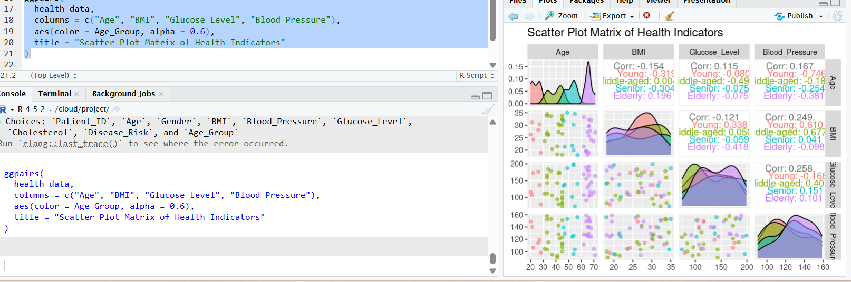

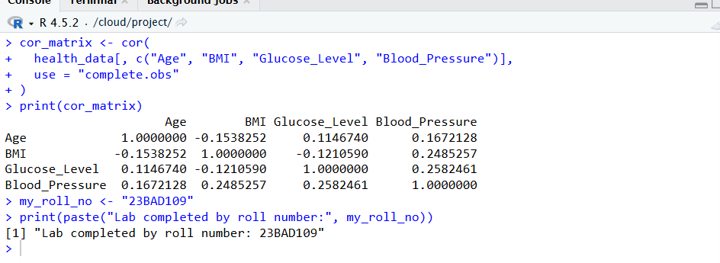

POST-LAB QUESTIONS (PROVIDE BRIEF ANSWERS TO THE FOLLOWING QUESTIONS)
1. Which health parameters show strong correlation?
BMI and glucose levels, as well as age and blood pressure, often show moderate to strong positive correlation.
2. Why correlation does not imply causation in medical data?
Because correlated variables may be influenced by hidden factors, and one variable does not necessarily cause changes in another.
3. How can these patterns assist predictive healthcare AI?
They help identify risk factors, improve feature selection, and enhance early disease prediction models.
4. What visualization limitations exist for high-dimensional data?
Limited screen space, visual clutter, overlapping data points, and reduced interpretability.
5. How can dimensionality reduction improve visualization?
Techniques like PCA reduce variables while preserving important patterns, making data easier to visualize and interpret.

ASSESSMENT
Description | Max Marks | Marks Awarded
Pre Lab Exercise | 5
In Lab Exercise | 10
Post Lab Exercise | 5
Viva | 10
Total | 30
Faculty Signature

